DATA FLOW DIAGRAMS FOR E WALLET MANAGEMENT SYSTEM

LEVEL 0 DFD : A Level 0 Data Flow Diagram (DFD), also known as a context diagram, provides a high-level overview of a system, illustrating the system's boundaries and its interactions with external entities. It serves as a foundational representation that highlights the main inputs and outputs without delving into the internal processes. In a Level 0 DFD, the entire system is represented as a single process, typically labeled with the system name, while external entities, such as users or other systems, are depicted as circles or rectangles. Arrows indicate the flow of data between the system and these external entities, showcasing how information enters and exits the system. This diagram is crucial for understanding the system's overall context and scope, making it an essential tool in the early stages of system design.

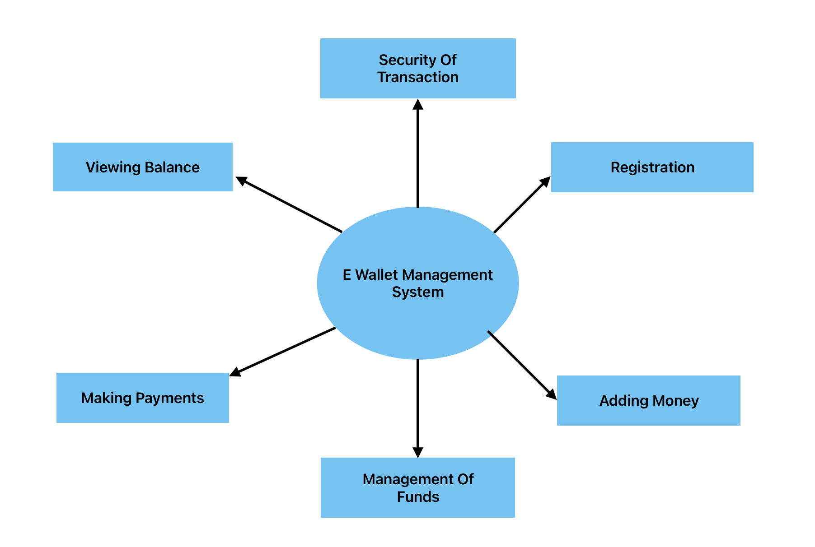

LEVEL 1 DFD : A Level 1 Data Flow Diagram (DFD) provides a more detailed view of a system than a Level 0 DFD, breaking down the main process from the context diagram into its sub-processes. In this diagram, the overall system is represented as a single process, but it is decomposed into multiple components or functions that illustrate how data flows between them. Each sub-process is labeled with a descriptive name, and data stores may be included to show where information is held within the system. External entities remain present, indicating where data originates and where it is sent. Arrows depict the flow of data between the processes, data stores, and external entities, allowing stakeholders to understand the specific interactions and operations that take place within the system. This level of detail helps in analyzing and designing system functionalities more effectively.

